

ARIHANT CHEMICAL CORPORATION
& J.J ENTERPRISE
For paints / inks / plastic / Rubber industries Raw material available with us under self import / Manufacturing / Trading.

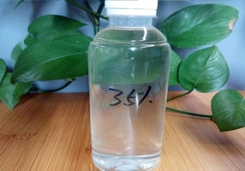Polyurethane Resin :- Specification

Product Description

UR5547 is a semi rigid, flame retardant polyurethane potting resin ideally suited to applications where small and delicate components are involved since the cured product exhibits very little stress, even when thermally cycled.

Features

- Conforms to UL94 V-O at 1.5mm thickness

- Low water absorption
- Excellent impact resistance
- Good adhesion to a wide variety of substrates
- Good electrical properties

Approvals: RoHS Compliant

UL Approval

Typical Properties:

Liquid Properties: Base Material

Density Part A - Resin (g/ml) Density Part B - Hardener (g/ml)

Part A Viscosity (mPa s @ 23ºC) Part B Viscosity (mPa s @ 23ºC)

Mixed System Viscosity (mPa s @ 23ºC) Mix Ratio (Weight)

Mix Ratio (Volume) Usable Life (20°C)

Gel Time (23°C) Cure Time (23 °C)

Cure Time (60 °C) Colour Part A - Resin

Colour Part B – Hardener Storage Conditions

Shelf Life Exotherm

(Measured on 100ml sample in a cylinder of diameter 49.4mm @ 23ºC)

Shrinkage

Regd Off: - Plot no 24 Block no .5, 1st floor, Behind Aurora cinema , opp Sahakari bhandar, Matunga (C.R) Mumbai – 400019
Administration /correspondence Office :- Plot No. 319,Room No.3, Ranchoddas Terrace building ,sir Bhalchandra Road, opp Hira House, Near Chhatre Maternity Hospital, Matunga (C.R) Mumbai – 400019 Tel :- +91 22 24148378 / 24146390
Mob :- MR NILESH MEHTA +91 9820142066 / +91 8850378208/+91 9029042066
Email Id :- info@arihantchemcorp.com, or nilesh@arihantchemcorp.com
Continue page 2...

Page 2...
ARIHANT CHEMICAL CORPORATION
& J.J ENTERPRISE
For paints / inks / plastic / Rubber industries Raw material available with us under self import / Manufacturing / Trading.

Polyurethane Resin :- Specification

Yes Meets
Polyurethane 1.69

1.23 24000

230 4000

5.52:1 4.01:1

  - Mins mins

  - hours hours Black Brown
Dry Conditions: Above 15ºC, Below 35ºC months

- 35ºC 1%

Cured System: | Thermal Conductivity (W/mK) | 0.35
 | Cured Density (g/ml) | 1.60
 | Temperature Range (°C) | -50 to +120
 | Max Temperature Range (Short Term °C / Mins) | +125
 | Dielectric Strength (kV/mm) | 14
 | Volume Resistivity (ohm-cm) | 10¹⁴
 | Shore Hardness | A85
 | Colour (Mixed System) | Black
 | Flame Retardency | No
 | Loss Tangent @ 50 Hz | 0.14
 | Permittivity @ 50 Hz | 5.00
 | Comparative Tracking Index | Not Measured
 | Water Absorption | < 0.5% / < 1%
 | (9.7mm thick disk, 51mm diameter) | < 0.5% / < 1%
 | 10 days @ 20ºC / 1 hour @ 100ºC
 | Elongation At Break | Not Measured

Regd Off: - Plot no 24 Block no .5, 1st floor, Behind Aurora cinema , opp Sahakari bhandar, Matunga (C.R) Mumbai – 400019
Administration /correspondence Office :- Plot No. 319,Room No.3, Ranchoddas Terrace building ,sir Bhalchandra Road, opp Hira House, Near Chhatre Maternity Hospital, Matunga (C.R) Mumbai – 400019 Tel :- +91 22 24148378 / 24146390
Mob :- MR NILESH MEHTA +91 9820142066 / +91 8850378208/+91 9029042066
Email Id :- info@arihantchemcorp.com, or nilesh@arihantchemcorp.com
Continue page 3...

Page 3...

ARIHANT CHEMICAL CORPORATION
& J.J ENTERPRISE
For paints / inks / plastic / Rubber industries Raw material available with us under self import / Manufacturing / Trading.

Polyurethane Resin :- Specification

Mixing Procedures

Resin Packs

It is important not to remove the aluminium outer wrapping until immediately before use. To open, cut the aluminium outer being very careful not to damage the inner pack.
When in Resin pack form, the resin and hardener are mixed by removing the clip and moving the contents around inside the pack until thoroughly mixed. To remove the clip, remove both end caps, grip each end of the pack and pull apart gently. By using the removed clip, take special care to push unmixed material from the corners of the pack. Mixing normally takes from two to four minutes depending on the skill of the operator and the size of the pack. Both the resin and hardener are evacuated prior to packing so the system is ready for use immediately after mixing. The corner may be cut from the pack so that it may be used as a simple dispenser.
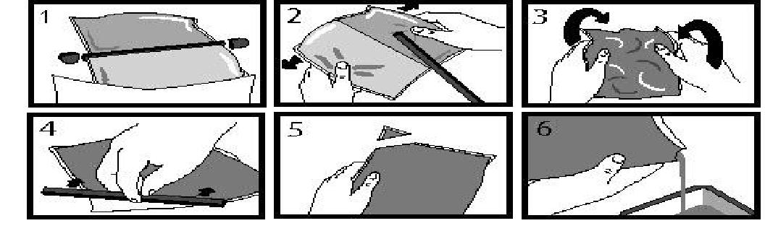

Bulk Mixing

When mixing, care must be taken to avoid the introduction of excessive amounts of air. Automatic mixing equipment is available which will not only mix both the resin and hardener accurately in the correct ratio but do this without introducing air. Containers of Part A (Resin) and Part B (Hardener) should be kept sealed at all times when not in use to prevent the ingress of moisture. Bulk material must be thoroughly mixed before use. Incomplete mixing will result in erratic or partial curing.

Regd Off: - Plot no 24 Block no .5, 1st floor, Behind Aurora cinema , opp Sahakari bhandar, Matunga (C.R) Mumbai – 400019
Administration /correspondence Office :- Plot No. 319,Room No.3, Ranchoddas Terrace building ,sir Bhalchandra Road, opp Hira House, Near Chhatre Maternity Hospital, Matunga (C.R) Mumbai – 400019 Tel :- +91 22 24148378 / 24146390
Mob :- MR NILESH MEHTA +91 9820142066 / +91 8850378208/+91 9029042066
Email Id :- info@arihantchemcorp.com, or nilesh@arihantchemcorp.com
Continue page 4...

Page 4...

ARIHANT CHEMICAL CORPORATION
& J.J ENTERPRISE
For paints / inks / plastic / Rubber industries Raw material available with us under self import / Manufacturing / Trading.

Polyurethane Resin :- Specification

General

Sedimentation of the resin has been minimised by careful attention to the formulation. However, any sediment which may have occured over long periods of time must be dispersed before removing any material from the container. This dispersion can be carried out (if necessary) by stirring with a broad bladed spatula or gently rolling the can. Take care not to introduce excessive amounts of air during this operation or it may be necessary to re-evacuate the resin. Sedimentation will be accelerated by storage at high temperatures. Sedimentation found in resin packs forms no problem since the sediment is re-mixed when the pack is used.

Additional Information

Curing Schedule

Do not heat cure large volumes immediately. Allow these to gel at room temperature and post-cure at high temperature if required (refer to liquid properties for details). Small volumes (250ml) may be heat cured immediately.

Cleaning

It is far easier for machines & containers to be cleaned before the resin has been allowed to cure. Electrolube’s OP9004 is a non-flammable cleaner designed for this purpose. Cured resin may be slowly softened and removed by soaking in our OP9003 Resin Stripper.

Storage

When storing under very cold conditions, the hardener may crystallise. If this occurs, simply warm (40°c) the container gently until all crystals have re-melted.

Health & Safety

Always refer to the Health & Safety data sheet before use. These can be downloaded from www.electrolube.com

Regd Off: - Plot no 24 Block no .5, 1st floor, Behind Aurora cinema , opp Sahakari bhandar, Matunga (C.R) Mumbai – 400019
Administration /correspondence Office :- Plot No. 319,Room No.3, Ranchoddas Terrace building ,sir Bhalchandra Road, opp Hira House, Near Chhatre Maternity Hospital, Matunga (C.R) Mumbai – 400019 Tel :- +91 22 24148378 / 24146390
Mob :- MR NILESH MEHTA +91 9820142066 / +91 8850378208/+91 9029042066
Email Id :- info@arihantchemcorp.com, or nilesh@arihantchemcorp.com

